

**CITIZENS FOR REGIONAL TRANSIT**

**617 Main St., Suite #201, Buffalo, NY 14203**

www.citizenstransit.org

**crtc@citizenstransit.org**

[C:\Geek Squad Data Backup\Documents and Settings\lynn\My Documents\CRTC\twitter logo 2.png](https://twitter.com/WNYTransit)



**KEEP US ON TRACK IN 2017**

Happy New Year! 2016 was a great year for CRT; you can keep it going in 2017. Join or renew now via [PayPal](https://www.paypal.com/cgi-bin/webscr?cmd=_xclick&business=crtc%40citizenstransit%2eorg&no_shipping=0&no_note=1&tax=0&currency_code=USD&bn=PP%2dDonationsBF&charset=UTF%2d8) or mail the attached form with a check to Citizens for Regional Transit, 617 Main St., Suite #201, Buffalo, NY 14203.

In 2016, CRT continued our efforts to promote public transit. Our major success this year was our campaign for a planning study by the City of Buffalo for a new train station with connections to Metro bus and rail as well as other modes of transportation. Mayor Byron Brown recently announced that there will be a study and CRT President Doug Funke has been appointed to serve on the committee! The Partnership for the Public Good played a central role in this accomplishment.

We also saw the inauguration of the Discover Niagara shuttle, a concept that CRT had championed in recent years with the Western NY Environmental Alliance. This shuttle will motivate visitors to leave their cars behind as they explore tourist attractions along the Niagara River between Niagara Falls and Old Fort Niagara. Over 30,000 tourists rode the trolley this inaugural year, before any significant advertising and promotions.

Throughout the year, we have been busy with letters, opinion pieces, and interviews in local media; meetings with State and Federal government representatives, presentations to community groups; information tables at events; comments on regional transportation plans and more.

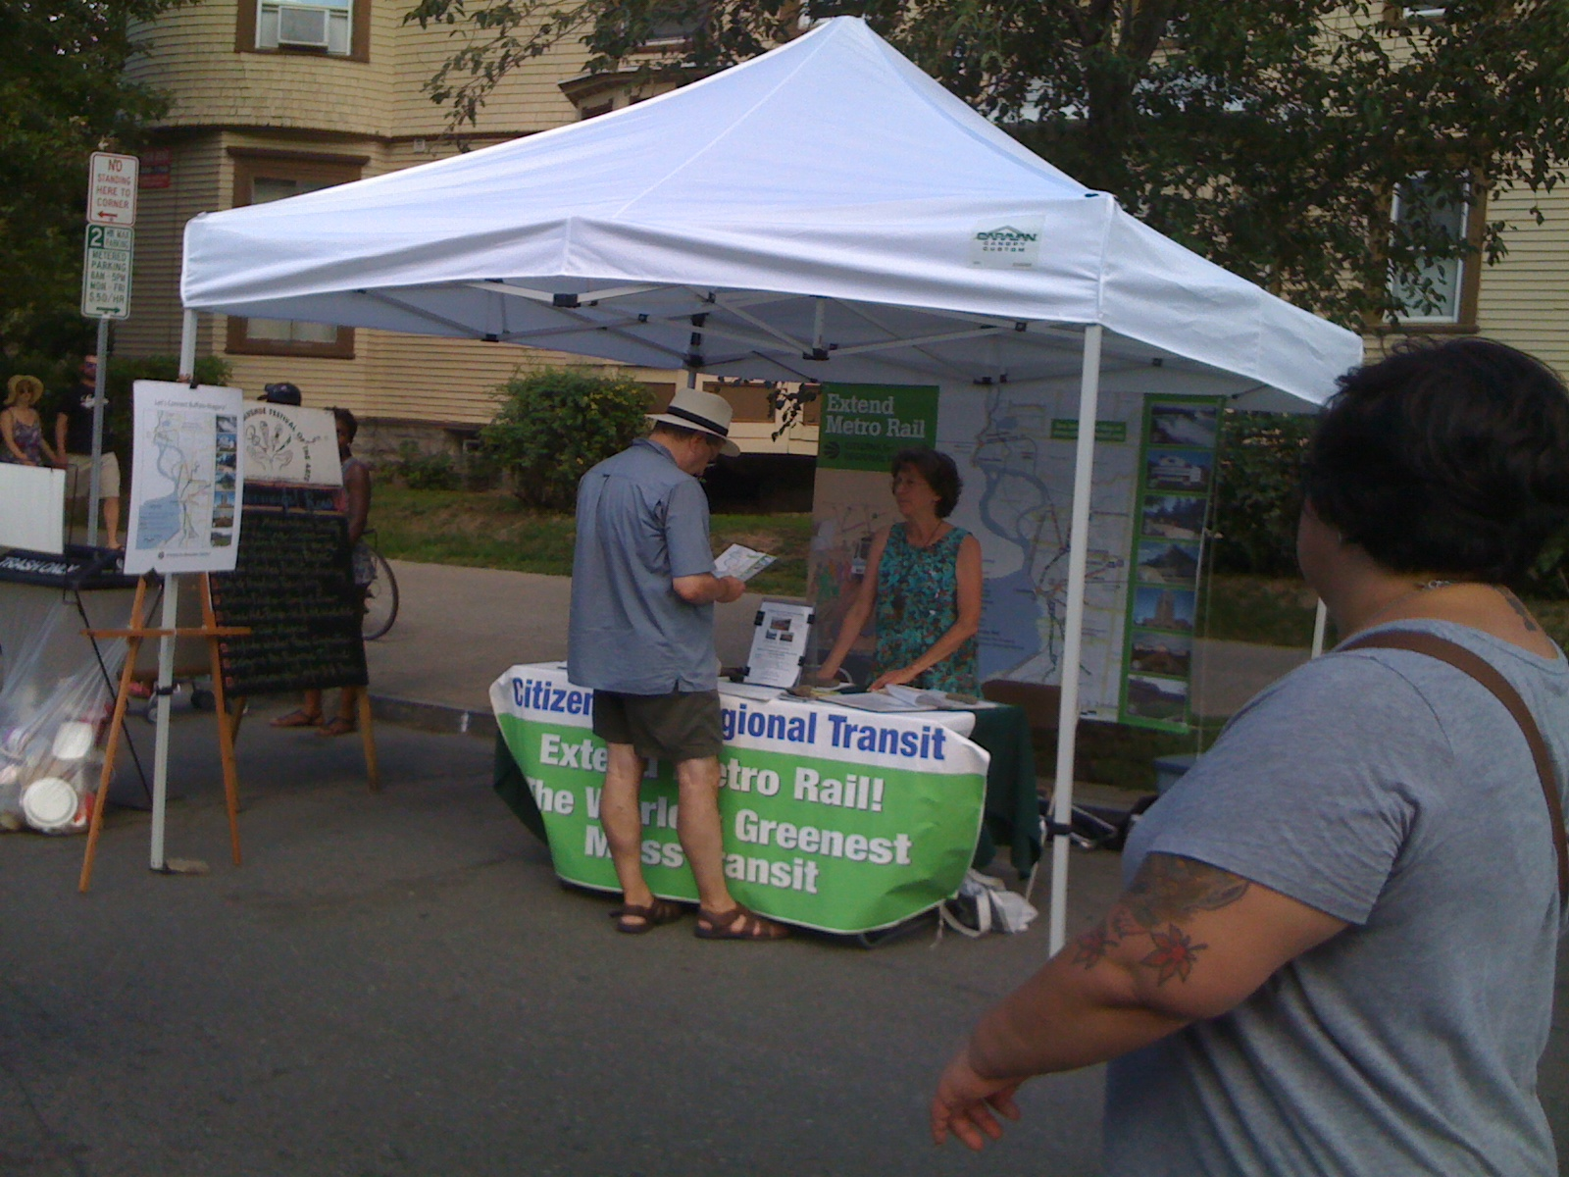 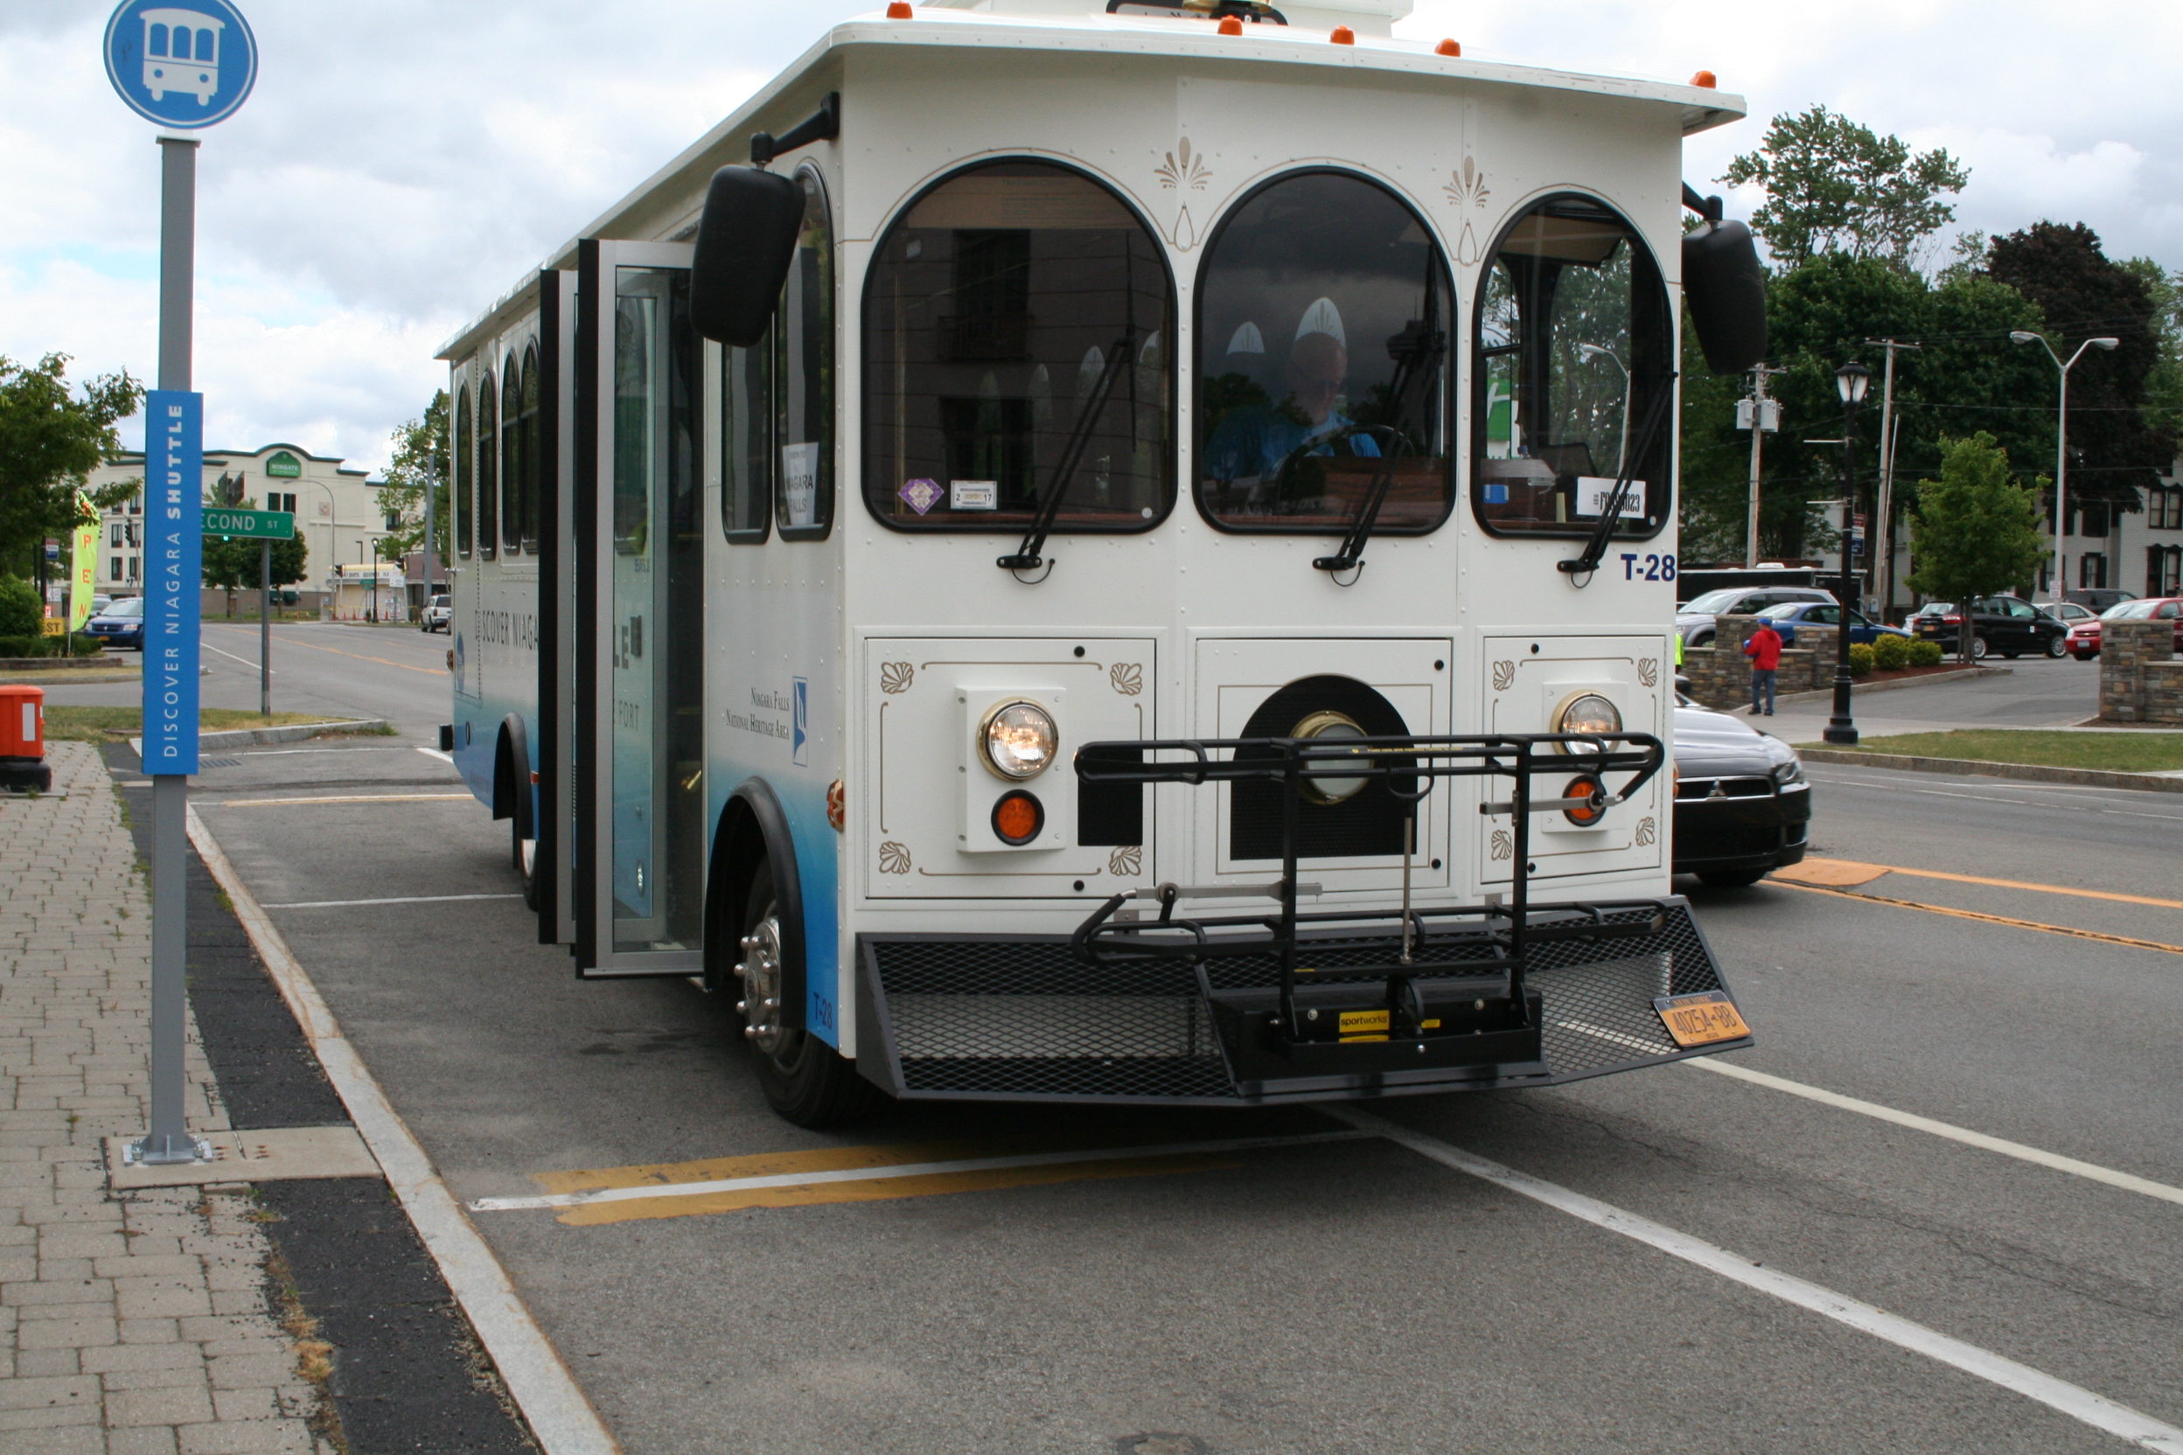

Elmwood Festival of the Arts Discover Niagara shuttle

CRT relies on members for all ongoing expenses. We are entirely staffed by volunteers, so contributions go directly to promoting transit. Your membership fosters our continuing and expanded efforts.

------ * ------ * ------ * ------ * ------ * ------ * ------ * ------ * ------ * ------ * ------ * ------ * -----



Citizens for Regional Transit

Membership Year- January 1 thru December 31, 2017

Name_______________________________________________________________________

E-mail_______________________________________________________________________

Street Address_________________________________________________________________

City/State/Zip__________________________________________________________________

Phone________________________________________________________________________

Suggested donation levels - check one for amount sent:

____ Corporate - name and logo will be shown on our website $250. or more

____ Group/organization $50.

____ Household $35.

____ Individual $25.

____ Student, senior, unemployed … $5.

**CRT is a registered 501(c)(3) nonprofit organization**

**and all contributions are tax deductible.**

------ * ------ * ------ * ------ * ------ * ------ * ------ * ------ * ------ * ------ * ------ * ------ * -----